Arjun Brar
Manga Character Profile Dossier · BAN240

Course: BAN240 | Document Type: Character Sheet | Date: June 6, 2026
Character: Arjun Brar | Role: Ensemble Warmth Engine | Prepared by: Stephen

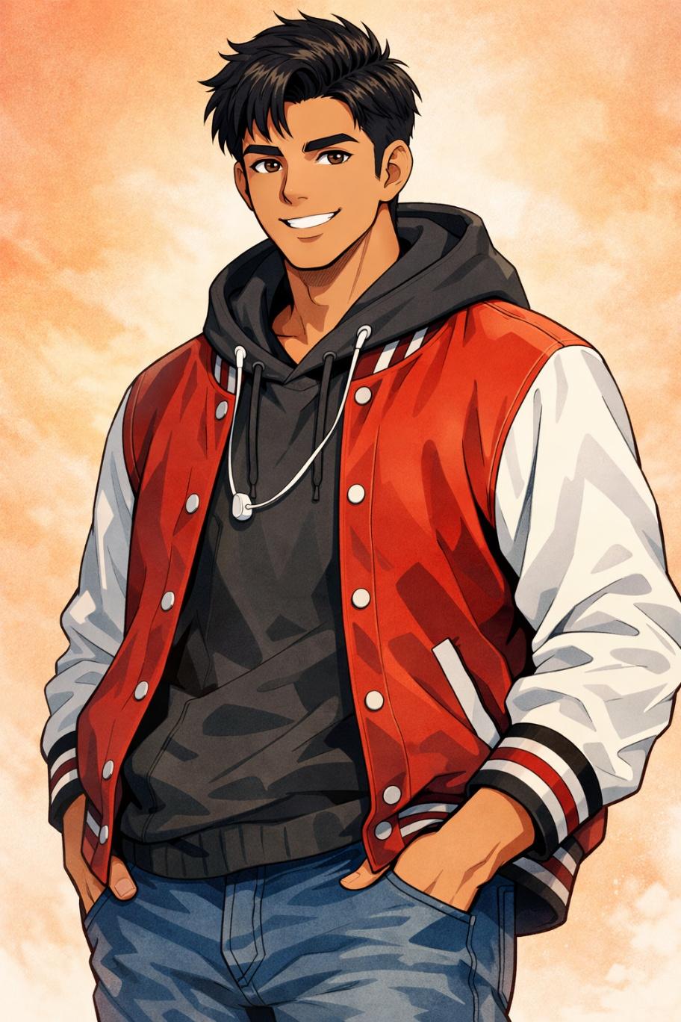
Section 01

Biographical Overview
Arjun is a fully realized manga character — a 22-year-old Punjabi international student whose easy charm, athletic confidence, and deep family pride make him one of the most immediately likeable people in any room. His real story — the weight of being the first in his family to study abroad — lives quietly beneath the swagger.
He came to Canada because his father said it was possible and his mother made him promise to call every day. He is keeping the promise.

"He is the character who makes the group feel like a group rather than a collection of individuals."
— Character Narrative Function Note

His arc is deceptively internal: the easy social confidence coexists with a private weight — being the first in his family abroad, working weekends he doesn't mention, missing the Gurdwara langar in a way he cannot fully explain to people who did not grow up with it. His most powerful scenes are not dramatic. They are the Sunday mornings at the Gurdwara, the paratha he wraps for himself and one extra, the moment he calls home and his mother answers before the first ring has finished.

Section 02

Demographics & Basic Information
Field | Detail
Full Name | Arjun Brar
Age | 22
Gender | Male
Ethnicity | Indian — Punjabi (Jat Sikh family)
Hometown | Ludhiana, Punjab, India
Current City | Brampton, Ontario, Canada
Living Situation | Shares a 3-bedroom house with four other Punjabi international students in Brampton's South Asian corridor — loud, communal, and always smelling like something being cooked
Immigration Status | International student visa
Languages | Punjabi (native) · Hindi (fluent) · English (fluent, with a warm Punjabi lilt that emerges under stress or excitement)
Occupation | Full-time undergraduate student + part-time warehouse work on weekends (contributes to tuition)
University | Toronto Metropolitan University (TMU)
Program | Business Analytics
Year | 2nd Year

Section 03

Physical Appearance & Manga Portrait Description

Physical Profile
Attribute | Description
Height | 6'0"
Build | Broad and athletic — hockey and kabaddi have done structural work; moves with an easy, unhurried physical confidence
Hair | Short dark hair under a navy patka (under-turban) on most days; occasionally a full navy or black dastar (turban) for important occasions; the patka is a core part of his daily aesthetic
Eyes | Dark brown, warm and direct — "genuine interest in you specifically" energy; sparkle mode activates for hockey and dhol beats
Skin Tone | Warm medium-brown with a slight golden undertone
Typical Outfit | Hockey jersey or Punjabi-brand tracksuit top, dark joggers, clean white or wheat-coloured Timberlands — effortlessly combining athletic and desi aesthetics
Accessories | Karha (steel Sikh bracelet) on right wrist — always; worn wallet chain; small khanda pendant; phone in front pocket at all times

Manga Art Style Notes
◆ Artist Direction
• Warmth panels: Literal background glow radiates when he laughs — warm amber-gold light emanating outward from behind the figure.
• Sparkle-eyes: Activated specifically for hockey goals and dhol beats; full shōnen sparkle treatment.
• Chibi mode: Triggered when homesick food lands perfectly — butter chicken or langar dal; small, soft, overwhelmed-with-feeling energy.
• Patka accuracy: The patka is always drawn respectfully and with detail; never a simplified shortcut; it is part of his visual identity at all times.
• "First in the family" moments: Drawn with quiet weight, no special effects — just stillness, a slight drop in the shoulders, eyes not meeting the reader. The silence does the work.
• Code-switch moments: Mid-sentence "yaar," "cha," "sahi hai" can be rendered in a slightly different speech bubble style — warmer, rounder — to mark the shift.

Section 04

Personality & Quirks
Arjun is naturally gregarious — he makes friends the way some people breathe: without effort, constantly, and in every direction. His social confidence is not performed. It is structural. He does not enter a room; the room reorganizes around him.
- Punjabi hospitality instinct is deep-wired: if you are in his space, you will be fed. This is not optional.
- Works weekends at a warehouse in Mississauga; never complains; considers it part of the deal.
- Has a specific, loudly held belief that Brampton is the best city in Canada and will explain this at length if given the opportunity.
- Plays hockey with a level of seriousness that surprises people who assumed he wouldn't know the sport — he grew up watching it obsessively via satellite; learned to skate in his first month in Canada.
- Morning playlist is exclusively Punjabi music; transitions to hip hop for study sessions. The playlist shift is his version of a mode change.
- Misses langar with a specific, physical nostalgia that no restaurant replicates; found the local Gurdwara within his first week and goes every Sunday.
- His Punjabi comes out fully when excited, which is often; mid-sentence code-switching to "yaar," "cha," "sahi hai" is constant.
- The house is his domain: he mediates roommate conflicts, organizes the communal grocery list, and knows whose turn it is to clean with military precision.

◆ Character Note — The Hidden Weight
The warmth and gregariousness are real — and so is what sits beneath them. The warehouse shifts he never brings up. The langar he cannot replicate. The call home where his mother picks up before the ring finishes. Arjun does not perform stoicism; he simply does not offer the weight unless you have earned the seat at the table.

Section 05

Hobbies & Interests
1 | Ice Hockey | Grew up watching NHL via satellite from Ludhiana; learned to skate in Canada within weeks of arriving; now plays in a recreational adult league. His slapshot is genuinely dangerous. Considers this the single best thing Canada introduced him to.
2 | Kabaddi | Played competitively in Punjab; follows the Pro Kabaddi League and World Kabaddi tournaments; tries to explain the sport to non-South Asian friends with decreasing patience and increasing enthusiasm.
3 | Punjabi Music & Bhangra | AP Dhillon, Sidhu Moosewala (deeply felt loss), Diljit Dosanjh, and classic bhangra. Dances at every function. Has done bhangra at a Canadian wedding uninvited and was welcomed immediately.
4 | Cooking Punjabi Food | Butter chicken, sarson da saag, makki di roti, dal makhani. Cooks for the whole house. Feeding people is how he expresses care.
5 | Gym & Fitness | Trains four mornings a week before class; considers this non-negotiable; has recruited two roommates who initially resisted.
6 | Gurdwara & Seva | Attends the local Gurdwara every Sunday; participates in langar preparation as seva. This is spiritual, cultural, and social simultaneously — the community he found in Canada.

Section 06

Sports Profile
Category | Sport / Detail
Primary Sport (Fan) | Hockey — Toronto Maple Leafs devotee. This was not inevitable, but it is now irreversible. Follows the NHL with the zeal of a recent convert who has done significant homework.
Primary Sport (Participatory) | Ice Hockey (recreational league) + Kabaddi (pickup games with diaspora community)
Secondary Sport (Fan) | Kabaddi — Pro Kabaddi League; follows the Punjab Warriors; watches with housemates on a cracked tablet propped on the kitchen counter
Anime Sports Influence | Blue Lock — understood it immediately as a story about what happens when ambition is structurally organized; applied its individual excellence philosophy directly to his hockey development

Section 07

Fandoms
Fandom | Description & Intensity
Toronto Maple Leafs | Recent but fierce convert; owns a jersey; has opinions about the roster. The zeal of someone who adopted a team rather than inherited one.
AP Dhillon | Primary music fandom; considers his crossover success a cultural moment; knows every track. Morning playlist anchor.
Diljit Dosanjh | The other pillar; Diljit's career is both entertainment and Punjabi pride. Followed consistently, devotedly.
Sidhu Moosewala | Felt loss. Listens to his music as both enjoyment and tribute. "295" is in every playlist — without exception.
Pro Kabaddi League / Punjab Warriors | Kabaddi is home. Follows it the way others follow their birth-city football club. Deep, unselfconscious loyalty.
Blue Lock | Manga convert; the individual excellence arc landed specifically and personally; actively applies its framework to his own hockey game.
WWE | Guilty pleasure retained from Punjab childhoods watching satellite TV; still watches PPV events with housemates. No irony.
Gurdwara Community | Not a conventional fandom — a devotional community that functions as his primary social and spiritual infrastructure in Canada. Foundational.

Section 08

Commute & Daily Life

The Commute
Leg | Detail
Home Base | Brampton — South Asian corridor, near Bramalea area
Route | Brampton Transit bus → Bramalea GO Station → GO Train → Union Station → TTC subway north to Dundas → walk to TMU
Duration | ~1 hour 15 minutes each way
Commute Mood | Punjabi music on the Brampton Transit leg; switches to hip hop or a hockey podcast on the GO train; genuinely enjoys the commute as decompression time
Signature Move | Falls into conversation with literally anyone who makes eye contact; has exchanged numbers with strangers on the GO train three times; considers this normal
Transit Pet Peeve | GO train delays on the Kitchener line — "Bhai, I have a lecture, not a suggestion."

On-Campus Routine
- Arrives with a paratha wrapped in foil from breakfast (cooked by whoever was up first in the house); eats it while walking; finds his people immediately.
- Sitting alone by choice is a concept foreign to him — he does not understand it and will resolve it for you whether you want him to or not.
- Lunch: Tiffin from home four days a week — always Punjabi, always enough for two people; shares without being asked.

Weekly Rhythm
Time | Activity
Weekday Mornings | Gym, 4 days per week - 45 minutes, before class, non-negotiable. Punjabi music only.
Weekday Afternoons | Class, campus, tiffin with whoever is nearby; study sessions with hip hop playlist running.
Weekday Evenings | Home to cook for the house; hockey on in the background; call home.
Saturday Morning | Warehouse shift in Mississauga — never mentioned, never complained about.
Saturday Afternoon | Recovery. Rest. Food. Hockey.
Saturday Evening | The house's unofficial social event — every week, without scheduling.
Sunday | Gurdwara — seva, langar, community. The week resets here.

Section 09

Character Role & Narrative Function
Arjun is the warmth engine of the ensemble — the character who makes the group feel like a group rather than a collection of individuals. In a school manga, he is the one who invites everyone, remembers what you said last week, and shows up with food without a reason.

Narrative Arc
His arc is deceptively internal. The easy social confidence coexists with a private weight: being the first in his family to study abroad; working weekends he doesn't bring up; missing the langar in a way he cannot fully explain to people who did not grow up with it.
◆ Most Powerful Scene Type
Not dramatic. The Sunday mornings at the Gurdwara. The paratha he wraps for himself — and one extra, always. The moment he calls home and his mother answers before the first ring has finished.

Ensemble Role Summary
Function | How It Manifests
Social Catalyst | Invites everyone; remembers details; pulls strangers into the group's orbit without effort
Warmth Anchor | The group feels safe because he is in it; conflicts settle when he is present
Cultural Bridge | Introduces non-South Asian characters (and readers) to Punjabi culture through action, not exposition
Internal Arc Carrier | Carries the diaspora first-generation weight quietly; his deepest scenes are private and still
Comedic Relief | The Brampton pride rants, the kabaddi explanations, the hockey convert certainty — all earned, all real

"His most powerful scenes are not dramatic — they are the Sunday mornings at the Gurdwara, the paratha he wraps for himself and one extra, the moment he calls home and his mother answers before the first ring has finished."
— BAN240 Character Narrative Notes
Arjun Brar — BAN240 Manga Character Sheet · Toronto Metropolitan University · Prepared June 6, 2026
Document prepared by Stephen · BAN240 Character Profile Dossier Series

